I would like to take part in the Retreat in Daily Life.
Sun 7th – Fri 12th Dec 2014

Name ……………………………………….………….

Address …………………………………..……………

…………………………………………….……….…..

…………………………………………………….……..

Mobile No. ………………………………….……….

Email …………………………………………………..

Preferred time for daily 30 minute meeting with Prayer Guide
If you are free to meet all morning / afternoon or evening please tick the box. Alternatively please give an approximate time period, e.g. 10-12. We cannot guarantee specific times until the opening meeting, but will try to accommodate your timetable.

 | Morning | Afternoon | Early Evening
Monday 8th
Tuesday 9th
Wednesday 10th
Thursday 11th
Friday 12th

Please Return to the Chaplaincy by MONDAY 1st DECEMBER.
Week of Guided Prayer
in Manchester Chaplaincy

Opening Meeting: Sunday 7th December 4.00-5.30pm
Meetings with guide: Monday 8th - Friday 12th
at a time to suit (30 mins)
Closing meeting: Friday 12th December at 4.30pm
“WAYS OF PRAYING” WORKSHOPS MONDAY, TUESDAY and THURSDAY EVENINGS 7.00pm (Attendance encouraged but voluntary)

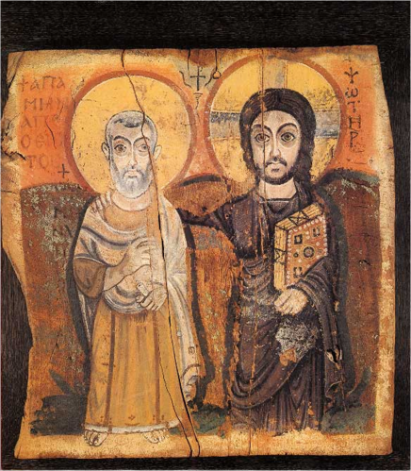

A Week of Guided Prayer is an opportunity to:
· Take time out
· Deepen your relationship with God
· Explore new ways of praying
· Find help with any kind of decision
· Discover who you really are
What is a Retreat in Daily Life?
It is a time of daily prayer (aiming at 30 minutes) and daily half-hour individual meeting with an experienced prayer guide. It lasts about a week.

Who is it for?
Anyone who is already Christian and who wants to deepen their prayer life, or someone who is not sure what they believe.

What is the programme?
As well as trying to pray for half-an-hour each day, reviewing how that prayer time went and 4 or 5 meetings with your prayer guide, the other components of the week are introductory and closing meetings. The first meeting is most important. The three workshops are voluntary but will prove extremely helpful.

Why do it?
When we are generous, God is more so. Even people who only took part because they felt sorry for their chaplain have got a lot out of the week. We encounter a God who loves and calls us. It can also be a great help in making or confirming decisions, big or small.

How much does it cost?
In principle nothing, the Chaplaincy is subsidising the event. Donations welcome.

As part of your planning, remember “Carols by
Candlelight” in the Holy Name, Wednesday 10th December.

Will it affect my studies or work?
Yes and no. You’ll be even busier that week because of these extra demands, hence the need to be generous. The retreat runs alongside your normal week, however, so you won’t miss any lectures, seminars or housework responsibilities. Sorry. You may need to spend less time on Facebook, going out or watching TV in order to make the space for prayer.

How do I sign up?
As soon as you know you want to participate, give your name and form in to the Chaplaincy, if possible during working hours, to Stephanie. It helps the organisers to know how many are taking part as soon as possible. We can still sometimes take people right up to the start of the retreat.

But I don’t know how to pray?
Join the club! Not a problem. That’s a great start. Come and see!

About the Retreat
The retreat is run by Stephen Hoyland, a layman who does this work in universities throughout the country. Stephen will lead the opening and closing meetings and the three workshops.

